TERMWORK 1

NAME: name

USN: 2GI20CSXXX

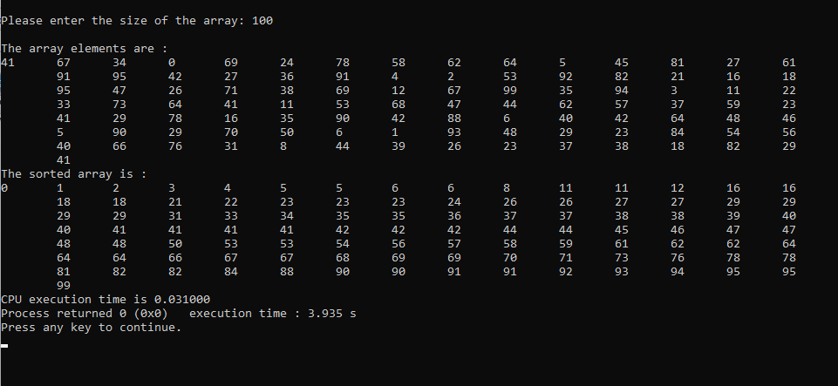

|  |  |
| --- | --- |
| **n** | **t** |
| 100 | 0.031 |
| 200 | 0.063 |
| 300 | 0.109 |
| 400 | 0.156 |
| 500 | 0.188 |